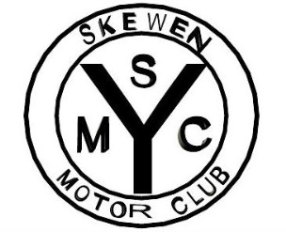
SKEWEN MOTOR CLUB
INVITE YOU TO ATTEND THE CLASSIC AND VINTAGE
CAR SHOW 2025
at Gnoll Country Park Neath SA11 3BS
17th August 2025
EXHIBIT DETAILS
Owners name …………………………………………………………………………………………………………………………..
Address……………………………………………………………........................…………………………………………………….
…………………...……………………………………...………......Post code …………………………………………………......…... Telephone number……………………………………………Email.......................................................................
Make…………………………………………………………….. Model……………….…………………………………..…………....
Year……………………………………………………………… Reg No……………...…………………………………………………
Club stand: YES / NO State Club……………………………………………………………………………………
Please Note: Disclaimer
I understand that my property will be brought to the show entirely at my own risk. I confirm that my entry will have as a minimum 3rd party insurance cover. Skewen Motor Club, or the Gnoll Country Park will not accept any liability for any damage howsoever caused to any vehicle or property on the showground or in transit. Skewen Motor Club have the right to refuse entry to any person or vehicle on the day. No loud music is to be played or revving of engines whilst on the showground. BBQ’s and any naked flames are prohibited on the showground. No vehicle movement is permitted on the field during event opening hours. If entering as a club, please arrive together.
ALL VEHICLES ARE TO BE ON THE SHOWGROUND BY 09.45AM AND REMAIN THERE UNTIL 4.00PM
Failure to adhere to any of these conditions will result in expulsion from the event.
Signed ……………………………………………………………………………………………………….
Please return the form by 1st August 2025 by post to:
The Event Secretary, Skewen Motor Club, 7 Lupin Close, Port Talbot. SA12 7AR
Late entries on the day will be charged £5.00 CASH ONLY proceeds will go to charity.
Please remember to include SAE only one envelope required for multiple entries.
NO SAE NO PASS

TO APPLY ONLINE PLEASE FILL OUT THIS FORM AND EMAIL IT TO
asmithsmc7@gmail.com

